Ex.No:- 16

Date:

**HIGH LEVEL PROGRAMMING EXTENSIONS**

**(PROCEDURES)**

**Program 1:**

Create a simple procedure to get all the records from the table ‘student_info’ which have the following data:

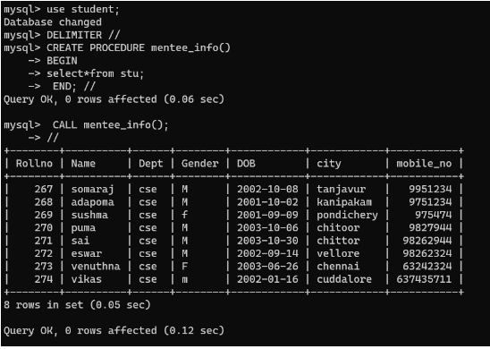

**Program 2:**

Create a stored procedure GetCustomerLevel() that accepts two parameters customer number and customer level.

